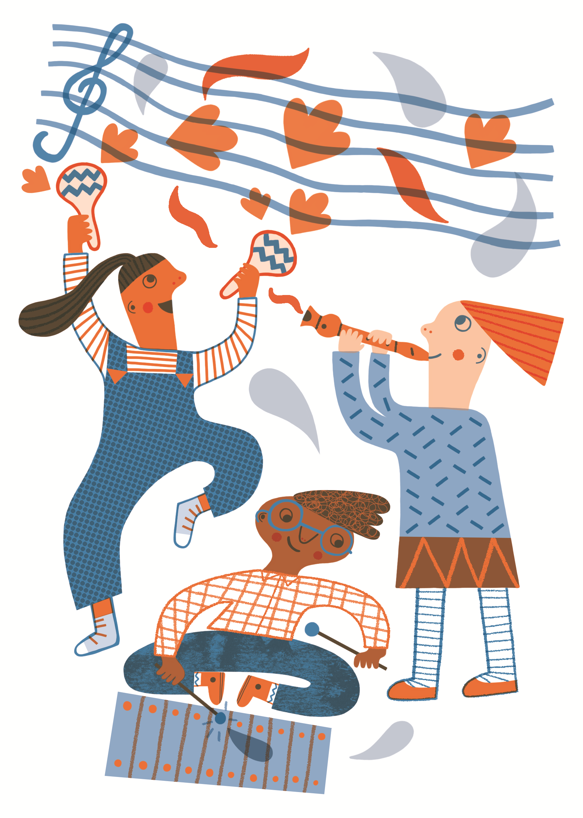
My Arts Award Discover Logbook

My name is………………………………………………………..

Contents

What is Arts Award? ……..………………………………........................................................................3
Your Arts Award Discover Logbook ……………………………………………….…..…………………4
Part A: Discover…………………………………………………………………………………………..……..…..5
Part B: Find Out …………………………………………..…………………………………………….…………..8
Part C: Share……………………………………………………………………………………………………...…..9
Appendices.…………………………..……………………………………………………………………………..10

What is Arts Award?

Arts Award supports young people to develop as artists and arts leaders. It is designed to inspire children and young people aged up to 25 to enjoy the arts, offering the chance to develop creativity, communication and leadership skills, and get recognised through national qualifications.

Arts Award Discover is for children and young people aged 5-9 or in Key Stage 1/lower Key Stage 2 at school. It gives them the opportunity to explore the arts in four sections:
- Part A: Discover – identify different art forms and take part in online arts activities to widen your experience and understanding of the arts, such as our Creating Music at Home activities
- Part B: Find out – find out about a BCMG artist and their work
- Part C: Share – reflect on your Arts Award experience and share your work with others.

Your Arts Award Discover Logbook

To help record your Arts Award we have created this logbook for you to complete. Fill in each section as you go. Once you have completed Sections A and B you can share your logbook remotely with a member of the learning team, via social media or with someone at home – sharing your Arts Award logbook and writing about the experience will complete the final section. You can complete you Arts Award Discover:

- Online
- Whilst at home
- With or without an instrument
- By yourself
- With others in your household
- Without having been to one of our workshops
- With support from BCMG’s learning team

To help you complete your Arts Award Discover, the appendices in the back of this book contain lists of other Arts Organisation and their websites, online arts activities and useful software and apps you may like to use to help record anything you create.

We will be available to offer support throughout.
Email learning@bcmg.org.uk to get in touch.

Part A: Discover

What is art?

Go for a walk round your house or local area and see how many different art forms you can see, hear or touch. Play bingo with the sheet below and check them off when you see them. Or you could create an Art Form Spotter Wheel (see p11) and take that with you.

Music | Dance | Poetry | Film
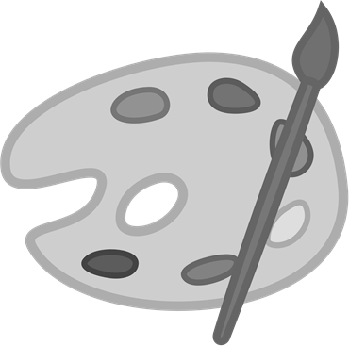  Painting | Photography | Drama | Drawing
Craft | Architecture | Design | Illustration
Ceramics | 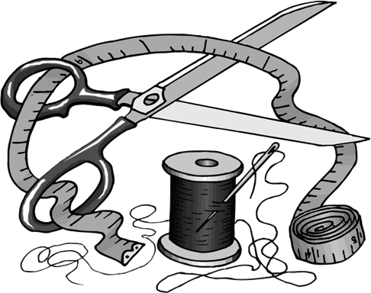  Sewing | Writing

Part A: Discover

Get Creative!

Look through the resources on our website and choose one activity from our Creating Music at Home collection. I chose to create music using:

This is me taking part (put your drawings/photos here):

Here’s a link to a recording of the music I made:

Part A: Discover

Now choose one further arts activity - this can be any of the art forms you have discovered or something else. There are lots and lots of ‘how to’ guides online, or you could simply sit down with pencils (or a paint brush and paints) and a piece of paper and create your very own artwork.

Put drawings and/or photos of you taking part in this arts activity in the space below:

Part B: Find Out

BCMG’s artists are at the heart of the work we do. Do some research on the BCMG Website here https://www.bcmg.org.uk/Pages/Category/musicians?Take=14 into our Musicians. Do you recognise any of them from BCMG events you've attended?
Email the Learning Team (learning@bcmg.org.uk) with a list of 3 - 5 questions you'd like a BCMG musician to answer. Think about what you might like to know, for example:
- How long have they played their instrument?
- Why did they choose their instrument?
- Who is their favourite composer and why?
If you want to know what their favourite food is, or whether they have any pets, please keep this to just one of your questions - the idea is that you learn more about the artist and what they do.
Draw a picture of the musician you’ve sent your questions to (or print out a picture from online)

Part B: Find Out
My Musician is:

They play:

My Questions & their answers:

Part C: Share
Think about what you did to complete each section of your Arts Award Discover.
In my Arts Award I am most proud of:

This is what I enjoyed the most in my Arts Award:

For me, the most challenging part of Arts Award was:

These are the new skills I have learnt from completing Arts Award:
For me, the most challenging part of Arts Award was:
........................................................................................................................................................................................
For me, the most challenging part of Arts Award was:
........................................................................................................................................................................................

For me, the most challenging part of Arts Award was:
........................................................................................................................................................................................

I shared my achievements with:

Arts Organisations | Description | Activity
BBC | The British Broadcasting Corporation (BBC) is a British public service broadcaster. | Make your own classical music here:  https://www.bbc.co.uk/teach/ten-pieces  Try out other BBC arts activities here:  www.bbc.co.uk/arts
Birmingham Museums | Birmingham Museums has 9 extraordinary venues that provide a fascinating glimpse into Birmingham's rich and vibrant past. | Explore the collections of each venue here:  www.birminghammuseums.org.uk/asset-bank/
English National Opera | The English National Opera is one of the UK's leading opera companies. | Learn more about opera here:  www.eno.org/discover-opera/
Ikon Gallery | Independent Art Gallery in Birmingham. | Explore the Ikon exhibitions digitally here:  www.ikon-gallery.org/whats-on/
National Theatre | The UK's leading Theatre | Watch a National Theatre Live Production here:  www.nationaltheatre.org.uk/nt-at-home
New Adventures | New Adventures is an iconic and ground-breaking British dance-theatre company, famous for telling stories with a unique theatrical twist. | Learn more about New Adventures here:  www.new-adventures.net
Tate Galleries | Tate Galleries are the leading modern art galleries in Britain. | Learn about different artists and try making your own art here:  www.tate.org.uk/kids
Wigmore Hall | One of the world’s great concert halls, specialises in chamber and instrumental music, early music and song. | Watch past Wigmore Hall performances here:  www.wigmore-hall.org.uk/wigmore-hall-live/past-live-streams
Appendices

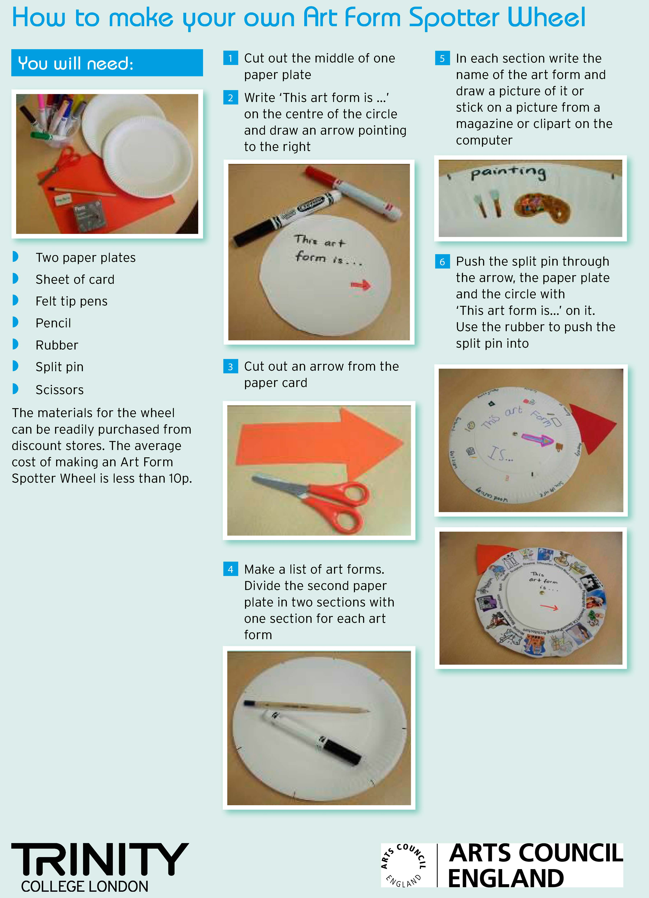
Appendices

