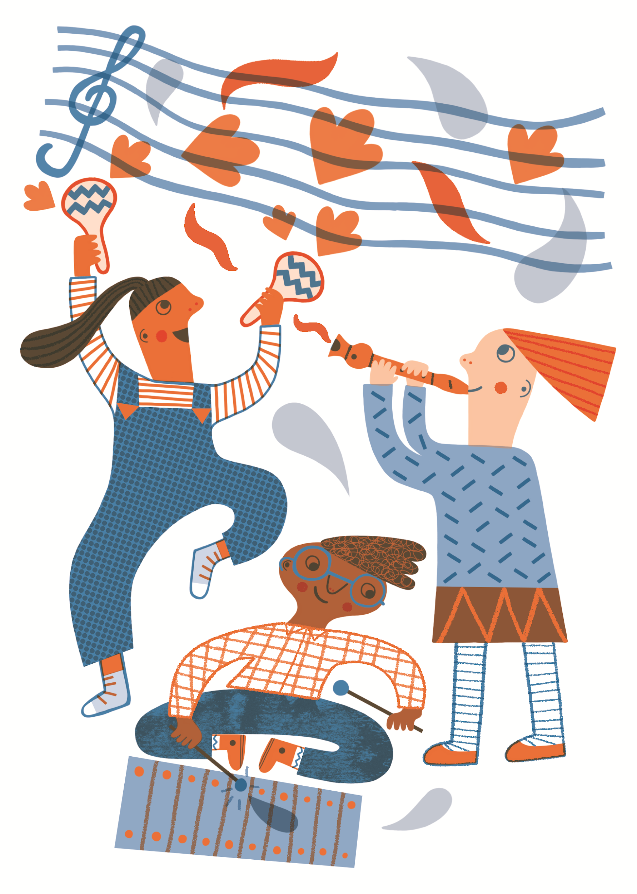
My Arts Award Explore Logbook

My name is………………………………………………………..

Contents

What is Arts Award?
……..………………………………........................................................................3
Your Arts Award Explore Logbook
……………………………………………………..……………………………………………….4
Part A: Inspire
……………………………………………………………………………………………………...5
Part B: Explore
………………………………………………………………………………………………..…….9
Part C: Create
…………………………………………………………………………………………….………..13
Part D: Present
……………………………….………………………………………………………………...….15
Submitting your Arts Award
………………….………………………………………………………………………………….17
Appendices
i) Logbook Checklist……………………………………………………………………...18
ii) Arts organisations list.……………………………………………………………….19
iiI) Ask Me Anything example questions………………………………………..20

What is Arts Award?

Arts Award supports young people to develop as artists and arts leaders. It is designed to inspire children and young people aged up to 25 to enjoy the arts, offering the chance to develop creativity, communication and leadership skills, and get recognised through national qualifications.

Arts Award Explore is for children and young people aged 7+. It gives them the opportunity to explore the arts in four sections:
- Part A: Inspire - take part in online arts activities that inspire you to be creative, such as our 'Composing Activities for Children'
- Part B: Explore - explore BCMG’s website, online resources and find out more about other Arts organisations
- Part C: Create - create music to demonstrate their arts skills and creativity through our Creating Music at Home activities
- Part D: Present – reflect on your Arts Award experience and share your work with others.

Your Arts Award Explore Logbook
To help record your Arts Award we have created this logbook for you to complete. Fill in each section as you go. Once you have completed sections A, B and C you can share your logbook remotely with a member of the learning team, via social media or with someone at home – sharing your Arts Award logbook and writing about the experience will complete the final section. You can complete you Arts Award Explore:

- Online
- Whilst at home
- With or without an instrument
- By yourself
- With others in your household
- Without having been to one of our workshops
- With support from BCMG’s learning team

To help you complete your Arts Award Explore, the appendices in the back of this book contain lists of other Arts Organisation and their websites, online arts activities and useful software and apps you may like to use to help record anything you create.

We will be available to offer support throughout.
Email learning@bcmg.org.uk to get in touch.

Activity 1: Tells us about the BCMG activity you have taken part in:

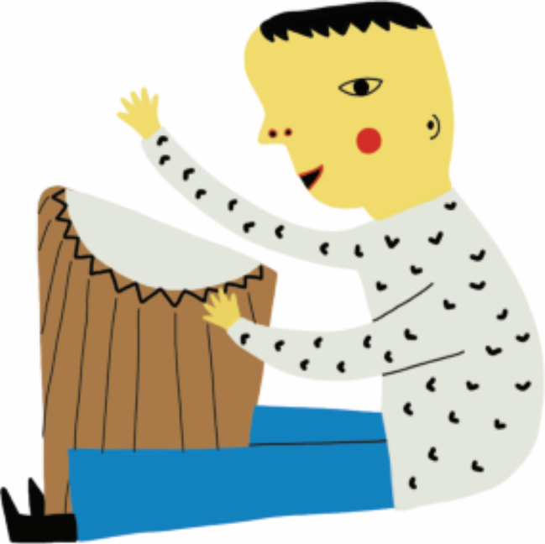
This is what I’ve learnt:

This is what I enjoyed most (and why):

What are you most proud of ?
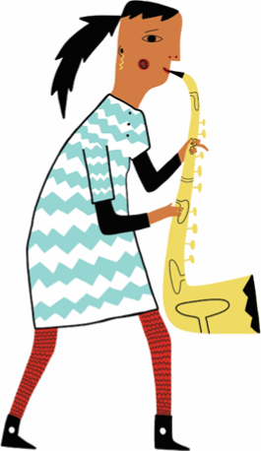
Put drawings and/or photos of you taking part in this arts activity in the space below:

Show us what you created! Use drawings, photos, recordings, videos and web links:

Activity 2: Tells us about the other arts activity you have taken part in:

This is what I’ve learnt:

This is what I enjoyed most (and why):

What are you most proud of?

Put drawings and/or photos of you taking part in this arts activity in the space below:

Show us what you created! Use drawings, photos, recordings and even web links.

Arts Organisation: BCMG
Visit www.bcmg.org.uk

BCMG stands for:
B
C
M
G

Three interesting facts about BCMG:
1.
2.
3.

Arts Organisation: BCMG

Which building is the home of BCMG?

Can you tell us something interesting about this building?

What sort of art does BCMG do?

What sort of arts professionals’ work at BCMG?

Draw a picture or find an image of the person you will be interviewing and put it here in your logbook

Arts Organisation: BCMG
ASK ME ANYTHING!
Tell us which musician or member of BCMG staff you will interview/research:

What questions will you ask this person about their job in BCMG?

What were their answers to your questions?

What else did you learn about this person’s job at BCMG?
My other arts organisation:
Which other arts organisation have you chosen to explore?

What type of arts organisation is this?

What sort of art activities does this arts organisation do?

Three other interesting facts about your chosen arts organisation:

Copy & paste or draw this arts organisation’s logo in the space below:

Look through the resources on our website choose a different activity from our Creating Music at Home or our Instrumentalists collection.
The name of the activity I chose to create my music was:

Tell us all about how you created your music:
What were the different steps of the music-making process?
What does your piece sound like? How did you choose which sounds/instruments to use?
How did you select which ideas to use?
You can add photos drawings, sketches, draft recordings, videos etc. to tell us about the process:

Show us....

Here’s a link to a recording/video of the music I made:

Part D: Present

Think about what you did to complete each section of your Arts Award Explore.
In my Arts Award I am most proud of:

This is what I enjoyed most in my Arts Award:

For me, the most challenging part of the Arts Award was:

These are the new skills I have learnt from completing Arts Award:
Part D: Present

I presented my achievements to:

Now tell us:
- What you shared
- Who you shared your Arts Award with
- When you shared your Arts Award
- How you shared your Arts Award

Comments from others—family/friends/BCMG learning team etc.

Logbook Checklist
Use the checklist below to tick off sections as you complete them. You can also leave comments for the Arts Award Advisor in the comment section.

Section | Task description | Comments | Completed
A: 1 | Take part in Activity 1
A: 1 | Complete Activity 1 write up in logbook
A: 1 | Collect evidence of your Activity 1 participation (recordings, photos etc)
A: 2 | Take part in Activity 2
A: 2 | Complete Activity 2 write up in logbook
A: 2 | Collect evidence of your Activity 2 participation (recordings, photos etc)
B: 1 | Complete the section about BCMG (use website)
B: 2 | Research/interview someone from BCMG
B: 2 | Write up your findings from interview/research in logbook
B: 3 | Research a DIFFERENT arts organisation
C: 1 | Choose a Music Maze or resource to create your music
C: 2 | Write about the process in your logbook
C: 3 | Provide evidence in logbook (recordings, photos, scores and drawings)
D: 1 | Think about your Arts Award and write about your experience
D: 2 | Share your Arts Award experience with an audience (via Zoom, a family member, your advisor or someone at school)
D: 3 | Provide evidence that the sharing took place (photos, screen shots, recordings etc).
D: 4 | Write about who you shared your Award with and get them to write some comments in your logbook
**** | Sign your assessor report form and return to BCMG
**** | Pay for the Arts award moderation on our website
**** | Email Advisor with completed moderation form

Date | Any other comments or questions for your advisor

Other Arts Organisation to Explore...

Arts Organisations | Description | Activity
BBC | The British Broadcasting Corporation (BBC) is a British public service broadcaster. | Make your own classical music here:  https://www.bbc.co.uk/teach/ten-pieces  Try out other BBC arts activities here:  www.bbc.co.uk/arts
Birmingham Museums | Birmingham Museums has 9 extraordinary venues that provide a fascinating glimpse into Birmingham's rich and vibrant past. | Explore the collections of each venue here:  www.birminghammuseums.org.uk/asset-bank/
English National Opera | The English National Opera is one of the UK's leading opera companies. | Learn more about opera here:  www.eno.org/discover-opera/
Ikon Gallery | Independent Art Gallery in Birmingham. | Explore the Ikon exhibitions digitally here:  www.ikon-gallery.org/whats-on/
National Theatre | The UK's leading Theatre | Watch a National Theatre Live Production here:  www.nationaltheatre.org.uk/nt-at-home
New Adventures | New Adventures is an iconic and ground-breaking British dance-theatre company, famous for telling stories with a unique theatrical twist. | Learn more about New Adventures here:  www.new-adventures.net
Tate Galleries | Tate Galleries are the leading modern art galleries in Britain. | Learn about different artists and try making your own art here:  www.tate.org.uk/kids
Wigmore Hall | One of the world’s great concert halls, specialises in chamber and instrumental music, early music and song. | Watch past Wigmore Hall performances here:  www.wigmore-hall.org.uk/wigmore-hall-live/past-live-streams

BCMG Ask Me Anything Questions

- What is your current job at Birmingham Contemporary Music Group?
- How long have you been working in your current job?
- How did you get into working for BCMG?
- What do you do as part of your job at BCMG?
- What do you enjoy most about your job?
- What do you find the most challenging about your job at BCMG?
- What has been your biggest personal achievement in your BCMG job?
- What is your favourite memory during your time at BCMG?
- What do you enjoy about working for BCMG?
- What advice would you give to somebody looking to work for an arts organisation?

